TNE20003 – Internet and Cybersecurity for Engineering Applications

Portfolio Task – Lab 2 Distinction Task

Aims:
- To subnet a network according to the given class address and network diagram
- Build and implement an addressed network according to the given network diagram below with addressing based on your subnetting in PT
- Achieve successful end-to-end connectivity of the addressed network implemented in PT

Preparation:
  - View “IP Subnetting" & “IP address and subnetting task-1” & “Network Addressing & Subnetting”
  - Using Self-Directed learning find out about Default Gateways
    - What are they?
    - What are they used for?
    - How do you implement them?
    - Which device(s) are they placed on?
  - Using Self-Directed learning find out about static routes
    - What are they?
    - What are they used for?
    - How do you implement them?
    - Which device(s) are they placed on?
  - Static routes are vital for you to be able to achieve end-to-end Connectivity.

Task Completion
- Upon completion of this task you are required to sit the online assessment relating to this lab under the “Quizzes” tab in Canvas. You will be awarded the grade if and only if you meet the requirements. If you do not meet the requirement you will be required to sit the online test for the lower grade. For example if you did the test for a D and did not get the 80% on the 2 attempts then you may take the test for a C.

Due Date:
- IT is advised that you complete the test at the end of the lab. If you do not then the absolute deadline is before the beginning of the lab in the following week.

Task 1.

Subnet and Address a Network According to Provided Requirements
In this task, you will
- Undertake the subnetting needed for the network shown in the diagram below and provide addressing for each
network/subnetwork in the diagram below.

Instructions
- Using the examples provided in the documents under the tutorial section under modules on Canvas for this unit,
carry out the relevant subnetting to completely address the network shown below.

100.200.100.0/21
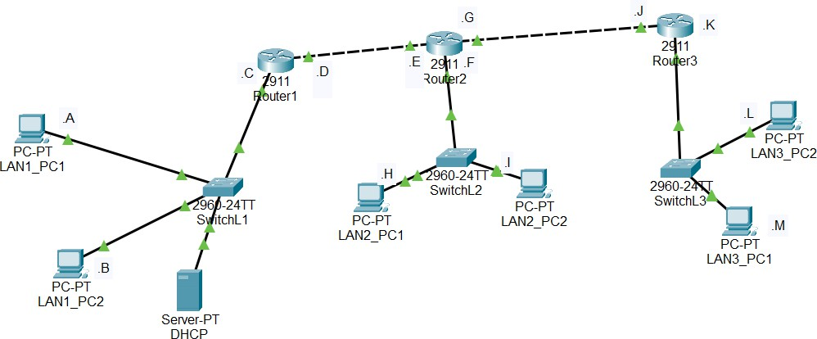
100.200.100.0/21
Some things you may want to consider are:
What class of network is the given address?
Class A – 100 (1-127)

How many networks are shown in the diagram? Identify them on the diagram.
5
Lan1,2,3 ,Router1-Router2 connection, Router2-Router3 connection
How many host addresses are possible per network/subnetwork?
We want to subnet into 5 networks therefore, 2³ = 8 > 5, meaning we need 3 more network bits.
Therefore 21+3 => /24 is the new subnet mask for the subnets, implying 2⁸ – 2 hosts bits => 254 for each subnet.
(/24 => increment = 2⁸ = 256)
Networks addresses:
- 100.200.100.0/24
- 100.200.101.0/24
- 100.200.102.0/24
- 100.200.103.0/24
- 100.200.104.0/24
You must complete the subnetting before class and upload it to Canvas. Your lab instructor will check your solution and advise you of any problems.

Task 2.

Build your newly addressed network on PT
- Refer to Lab2 P if you need help on how to implement the network.

Instructions:

Carry out some basic connectivity tests.
  - Click on Lan1_PC1 and choose “desktop” and then click on the “command prompt”
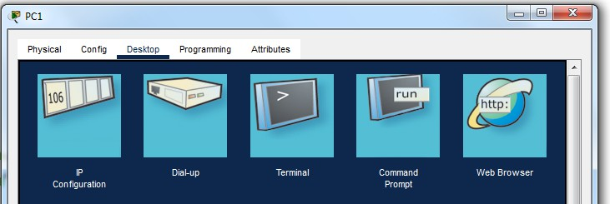
  - In the “command prompt” window type “ping Router1.C”
  - Note what is displayed. Did the ping work?
Reply from 100.200.100.3, yes ping worked.

  - In the “command prompt” window type “ping LAN1_PC2”
  - Note what is displayed. Did the ping work?

Reply from 100.200.100.2, yes ping worked.

  - In the “command prompt” window type “ping Router1.D”

  - Note what is displayed. Did the ping work?

Request time out, ping did not work

- Communicating to Router1.D
  - From task 1 above you should remember that you were not able to ping Router1.D from either LAN1_PC1 or
LAN1_PC2, but you were able to ping Router1.C.
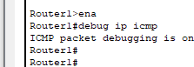

  - On Router1 issue the following command to enable you to see the ICMP traffic that is sent when you generate a
ping or traceroute. Click on Router1 and choose CLI tab at the top. Press enter, then follow the commands in the
graphic below:

Note that to move from the viewer mode (Router1>) to the enable mode (Router1#) you need to type the word enable.
  - Go to LAN1_PC1 and enter the following command ping Router1.C -n 10. This will send 10 ping packets to that
n/w address. Then click on Router1 and look at the CLI screen. What do you see???
10 echo replies sent to PC1
  - This output shows that the ping packets are being sent by the PC and are arriving at Router1. In Router1 hit enter a few times to enable you to separate the actions of the previous activity with the next one.
  - Now go back to LAN1_PC1 and enter the following command ping Router1.D -n 10. This will send 10 ping packets to that n/w address. Then click on Router1 and look at the screen. What do you see???
No echo replies are sent
  - What is different between steps c) and e) that might explain the different outcomes???

    - You will need to investigate the reason for this outcome and troubleshoot it to find the solution and then implement the solution at each of the PCs on the 3 LANs.

- PCs do not have their default gateway configured to the router interface part of their subnet.

Once you can successfully communicate across Router1 to the address of Router1.D,

then we can look at communicating to the end PCs of LAN2 and LAN3.
  - More self-directed learning will be required to determine how the packets can be transferred through the routers to the correct destinations.
  - Note that there are 2 possible ways of achieving this outcome. Please use the method outlined in the “preparation” part of this lab.

Once you have implemented the method in 2 above issue a ping from LAN1_PC2 to LAN2_PC1 and then LAN3_PC2.
  - Comment on the outcome of the ping.
Pings are successful

Now issue the command “tracert” from LAN1_PC2 to LAN2_PC2.
  - Comment on the outcome of the tracert command.
Successfully reaches LAN2_PC2, 100.200.101.2

You should also investigate issuing a traceroute between all endpoints (ie PCs in different LANs) of your network and record your findings.

~~~~~ End of Lab ~~~~~

